 



Database Programming with SQL 6-1: Cross Joins and Natural Joins Practice Activities

# Objectives

* Construct and execute a natural join using ANSI-99 SQL join syntax
* Create a cross join using ANSI-99 SQL join syntax
* Explain the importance of having a standard for SQL as defined by ANSI
* Describe a business need for combining information from multiple data sources

# Vocabulary

Identify the vocabulary word for each definition below.

|  |  |
| --- | --- |
| **CROSS JOIN** | Returns the Cartesian product from two tables. |
| * **NATURAL JOIN** | Joins two tables based on the same column name. |

# Try It / Solve It

Use the Oracle database for problems 1-3.

1. Create a cross-join that displays the last name and department name from the employees and departments tables.

SELECT last_name, first_name, department_name

FROM employees CROSS JOIN departments;

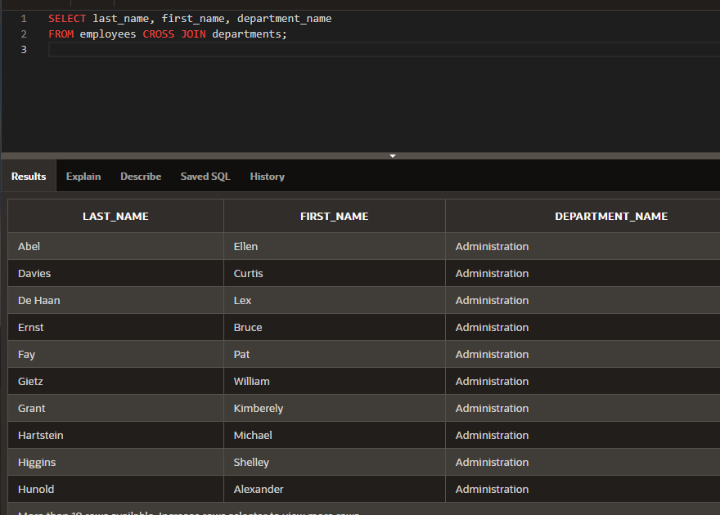

1. Create a query that uses a natural join to join the departments table and the locations table. Display the department id, department name, location id, and city.

SELECT department_id,department_name, location_id, city

FROM departments NATURAL JOIN locations;

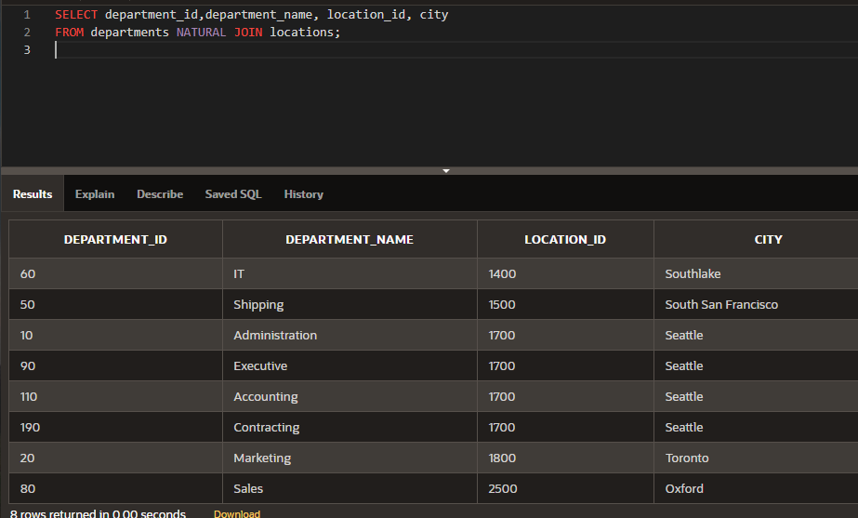

1. Create a query that uses a natural join to join the departments table and the locations table. Restrict the output to only department IDs of 20 and 50. Display the department id, department name, location id, and city.

SELECT department_id,department_name, location_id, city

FROM departments NATURAL JOIN locations

WHERE department_id in (20, 50);

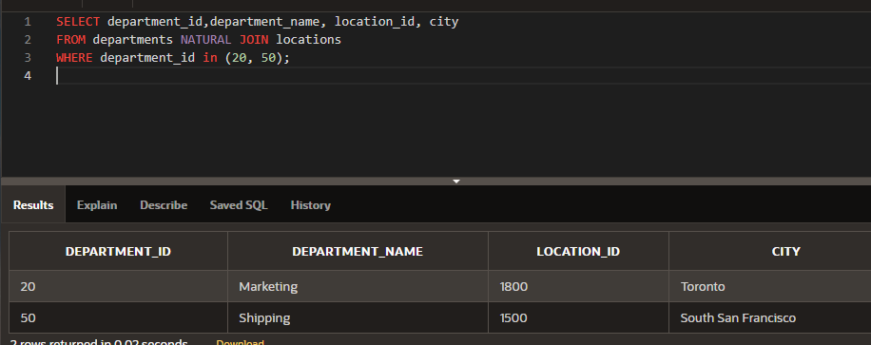

Copyright © 2020, Oracle and/or its affiliates. All rights reserved. Oracle and Java are registered trademarks of Oracle and/or its affiliates. Other names may be trademarks of their respective owners.